Question: **Design a Python Script to print a spiral pattern for a 2-dimensional matrix.**

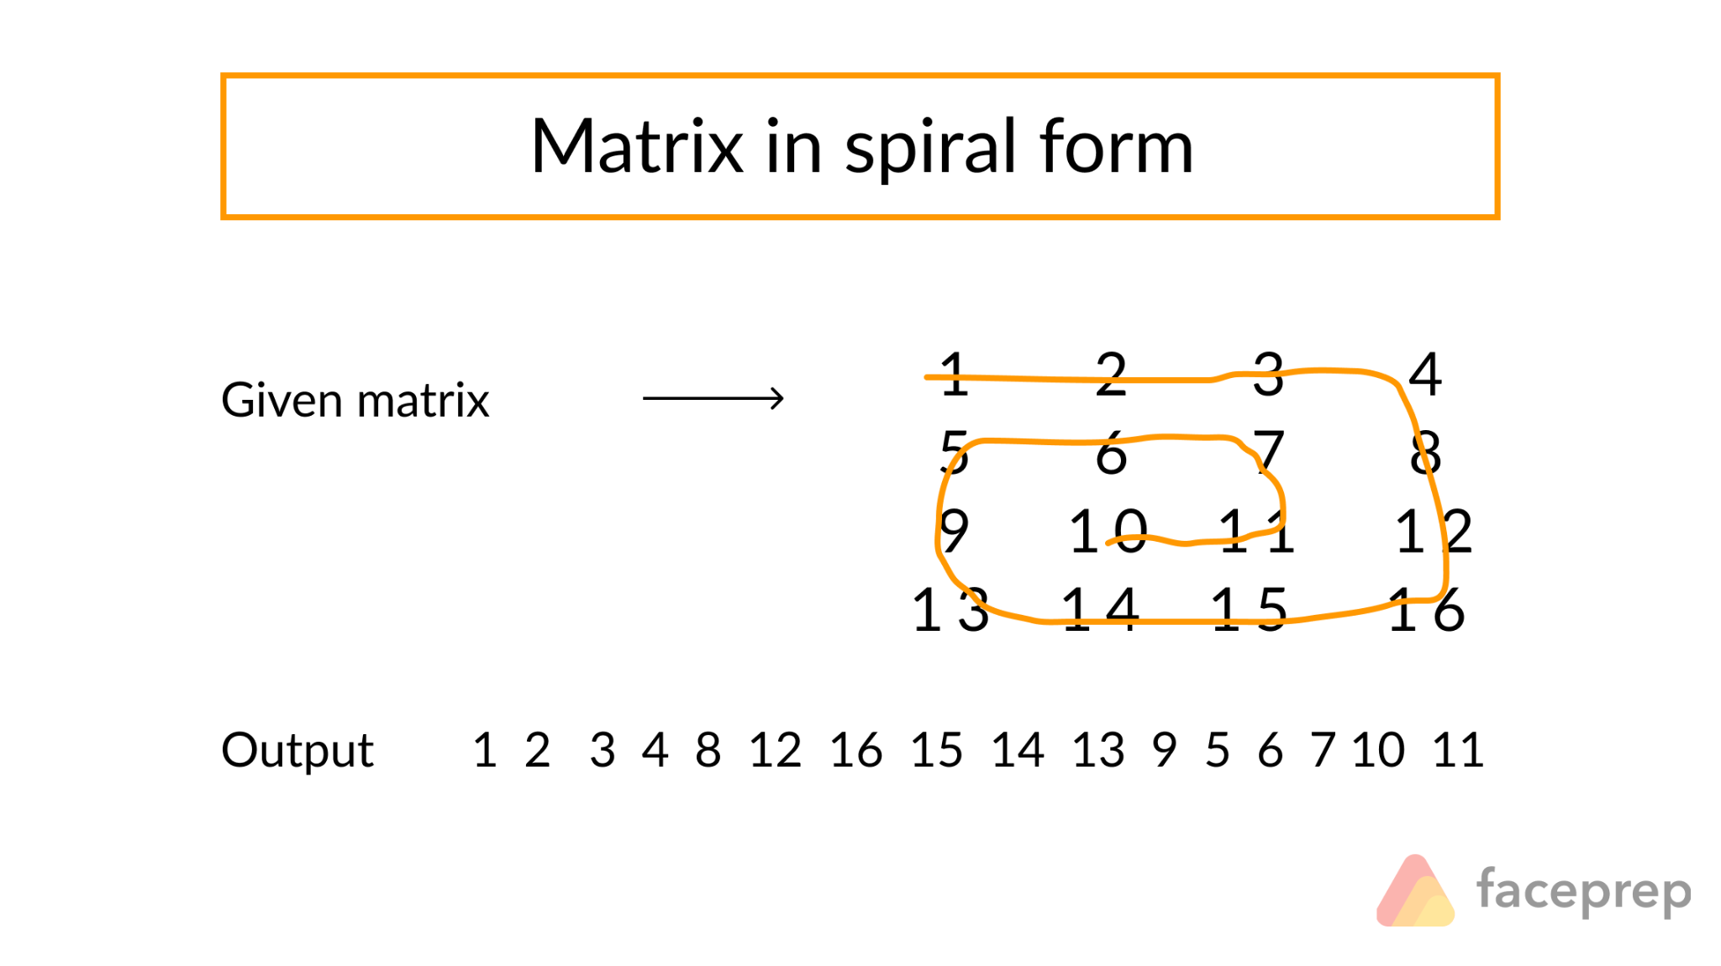

Approach: **Loop approach**

We are solving the problem by dividing the matrix into loops or squares or boundaries. As it is seen that the elements of the outer loop are printed first in a clockwise manner then the elements of the inner loop are printed. So printing the elements of a loop can be solved using four loops which prints all the elements. Every ‘for’ loop defines a single direction movement along with the matrix. The first for loop represents the movement from left to right, whereas the second crawl represents the movement from top to bottom, the third represents the movement from the right to left, and the fourth represents the movement from bottom to up.

**Algorithm:**

**1**.Create and initialize variables row_begin– starting row index, row_end –ending row index, col_begin– starting column index, col_end – ending column index.

**2**.Run a loop until all the squares of loops are printed.

**3**.In each outer loop traversal print the elements of a square in a clockwise manner.

**4**.Print the top row, i.e. Print the elements of the row_begin’th row from column index col_begin to col_end, and increase the count of row_begin.

**5**.Print the right column, i.e. Print the last column or (col_end-1)th column from row index row_begin to row_end and decrease the count of col_end.

**6**.Print the bottom row, i.e. if row_begin < row_end, then print the elements of (row_end-1)th row from column col_end-1 to col_begin and decrease the count of row_end.

**7**.Print the left column, i.e. if col_begin < col_end, then print the elements of col_beginth column from row_end-1th row to row_begin and increase the count of col_begin.

**(3 X 3 Matrix)**

|  |  |  |  |
| --- | --- | --- | --- |
| Row_end(→)  Row_begin (↓)  column_begin(→)  column_end(↓) | 0 | 1 | 2 |
| 0 | 1 | 2 | 3 |
| 1 | 4 | 5 | 6 |
| 2 | 7 | 8 | 9 |

**By**

**IOT GROUP-1**

122010406001-Bharathi Charan

122010406002-Mitra Teja

122010406003-Sai Rahul

122010406004-Sai Nithin